Hiep Ha

CS-230

Professor Samuel Haney

May 19, 2024

1-5 Assignment: UML Diagram

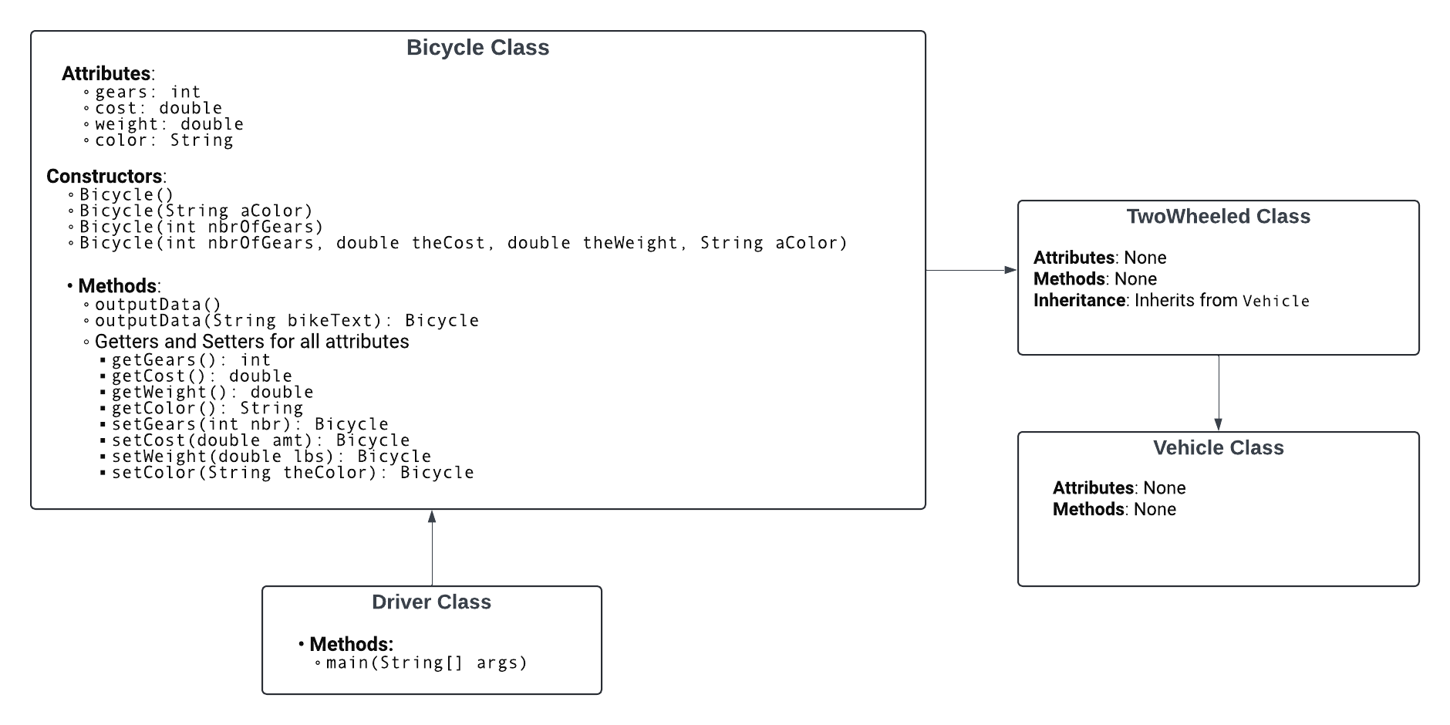

Explanation of Object-Oriented Programming Principles

1. **Inheritance:**

TwoWheeled inherits from Vehicle.

Bicycle inherits from TwoWheeled.

This demonstrates a hierarchical relationship where Bicycle is a type of TwoWheeled vehicle, and TwoWheeled is a type of Vehicle.

1. **Encapsulation:**

Bicycle class encapsulates its properties (gears, cost, weight, color) as private attributes.

Public getters and setters are provided to access and modify these private attributes.

1. **Method Overloading:**

The Bicycle class has multiple constructors with different parameter lists, showcasing method overloading.

outputData method is also overloaded to accept a string parameter.

1. **Method Chaining:**

The setter methods in the Bicycle class (setGears, setCost, setWeight, setColor) return the current instance (this), allowing for method chaining.

1. **Polymorphism:**

Demonstrated in the Driver class where instanceof checks are used to determine the type of the object at runtime. This shows how objects of the parent class can be used to refer to objects of the child class (Bicycle is-a TwoWheeled, TwoWheeled is-a Vehicle).